**Insirance covergaeThank You**

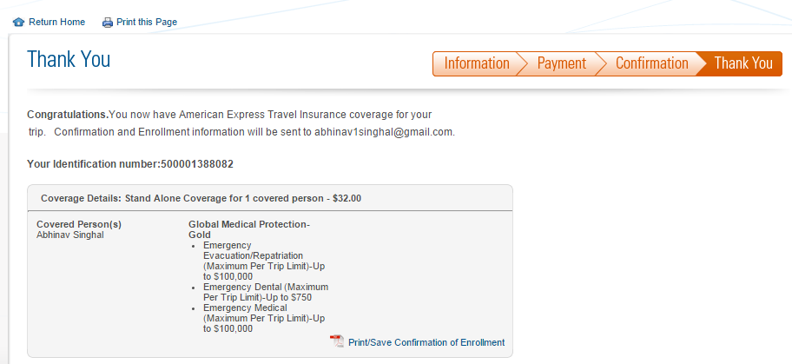

Customer Thankyou Page

**Congratulations.**You now have American Express Travel Insurance coverage for your   
        trip.   Confirmation and Enrollment information will be sent to abhinav1singhal@gmail.com.

**Your Identification number:500001388082**

**Coverage Details: Stand Alone Coverage for 1 covered person - $32.00**

**Covered Person(s)**

Abhinav Singhal

**Global Medical Protection-Gold**

* Emergency Evacuation/Repatriation (Maximum Per Trip Limit)-Up to $100,000
* Emergency Dental (Maximum Per Trip Limit)-Up to $750
* Emergency Medical (Maximum Per Trip Limit)-Up to $100,000

[Print/Save Confirmation of Enrollment](https://www295.americanexpress.com/travel-insurance/thanks.do#99)